

APSCI BOARD MEMBERS
PRESIDENT BOBBY NESS
SENIOR VICE PRESIDENT LOREN MYHILL
JUNIOR VICE PRESIDENT JOLYANE SOPLANDA
TREASURER SUSIE MYHILL
SECRETARY MARY PERRY
DIRECTOR CAROL SLAVIK
DIRECTOR DAVE MATTHEWS
DIRECTOR TERESA SELLERS
DIRECTOR MAUREEN TRACY
ALTERNATE DEBBIE CARPENTER
ALTERNATE JOHN HARRIS
ALTERNATE SUE LOVELAND

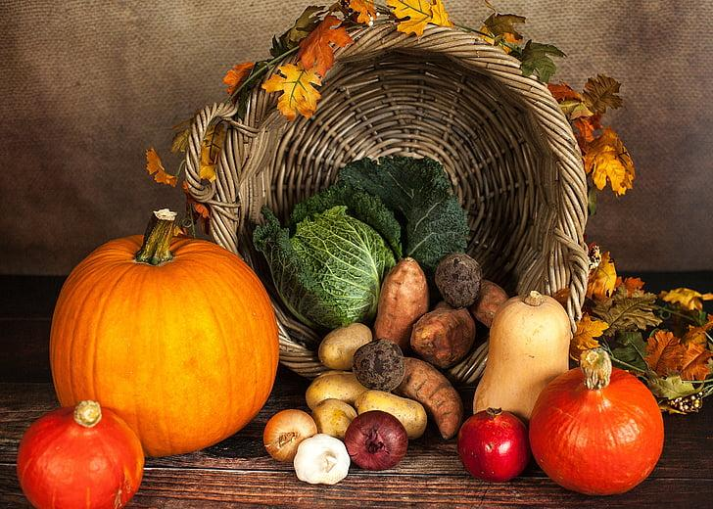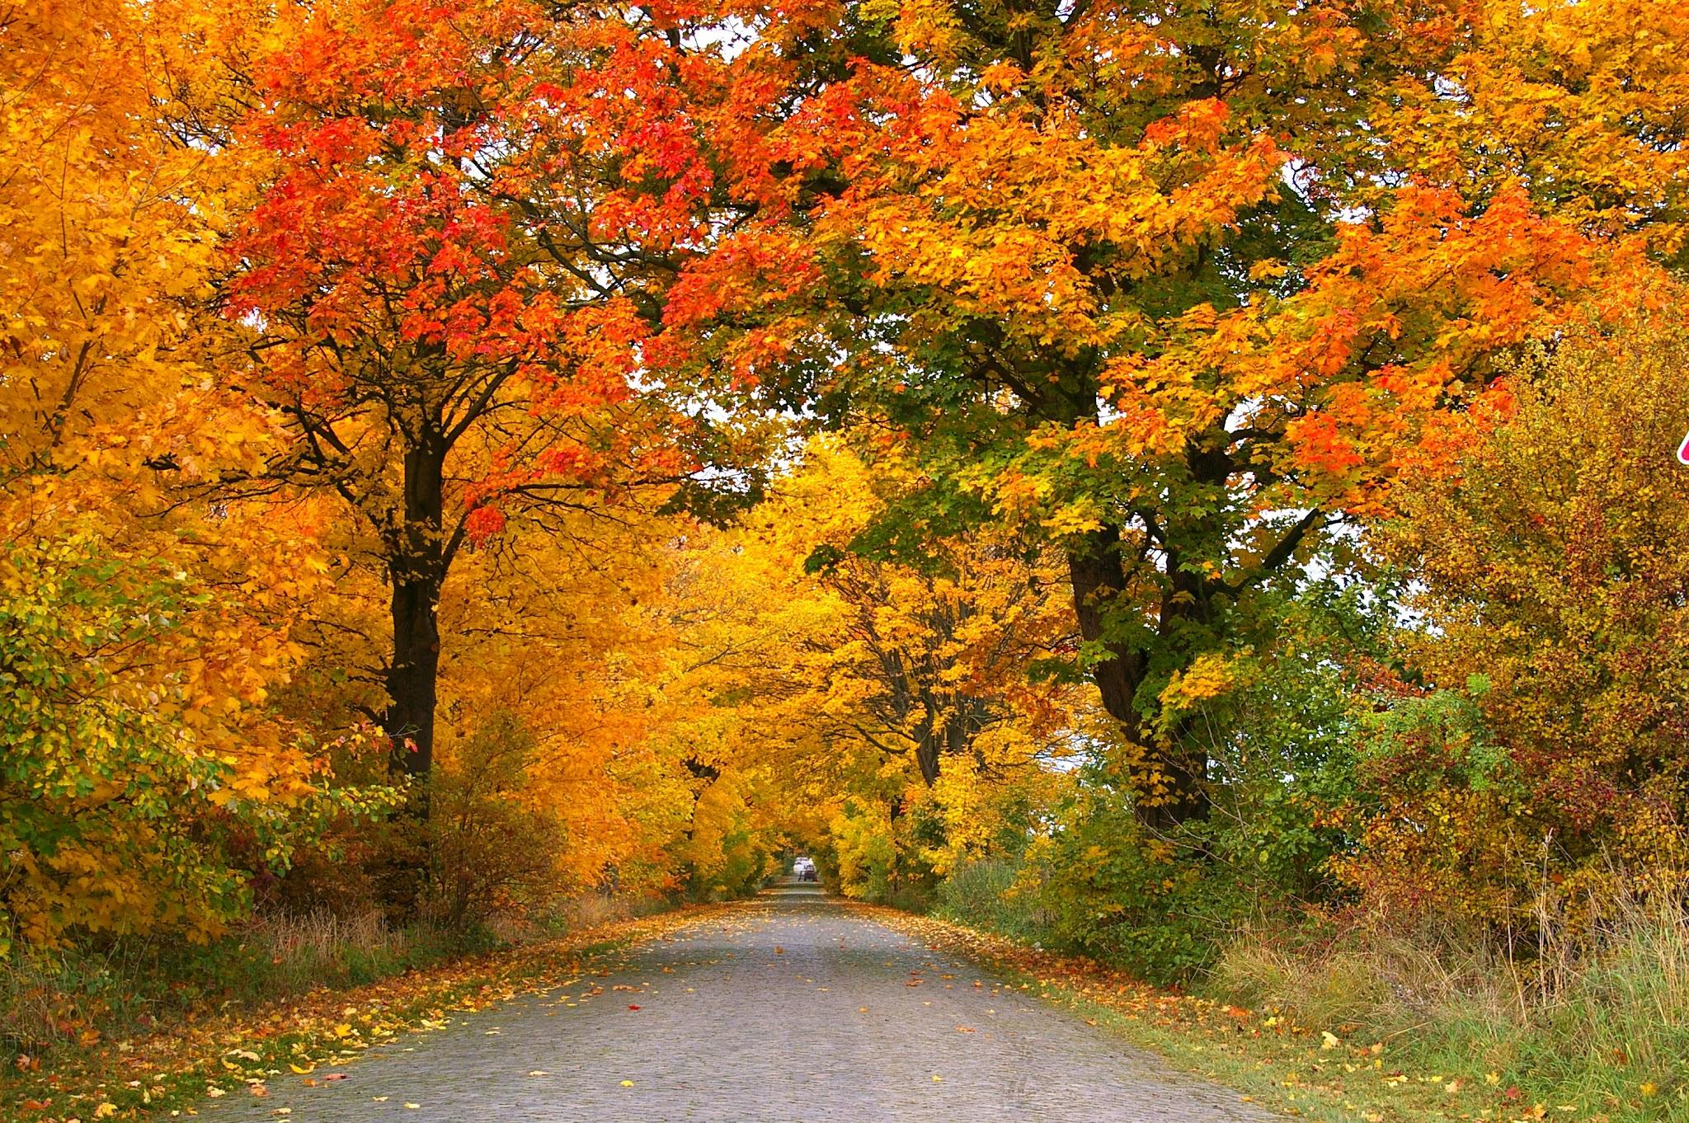

Anchor Point Senior Citizens, Inc
72750 Milo Fritz
PO BOX 438
Anchor Point, AK 99556
907-235-7786
apsci@acsalaska.net
anchorpointseniorcenter.com


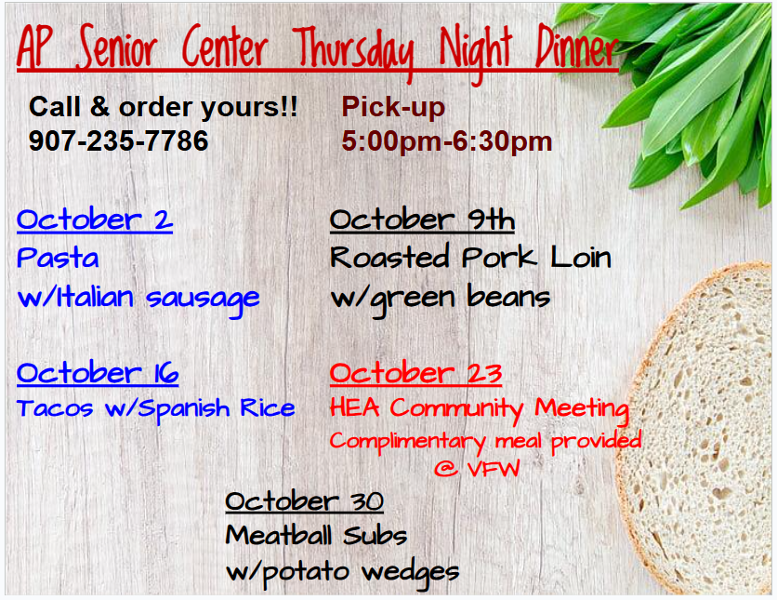

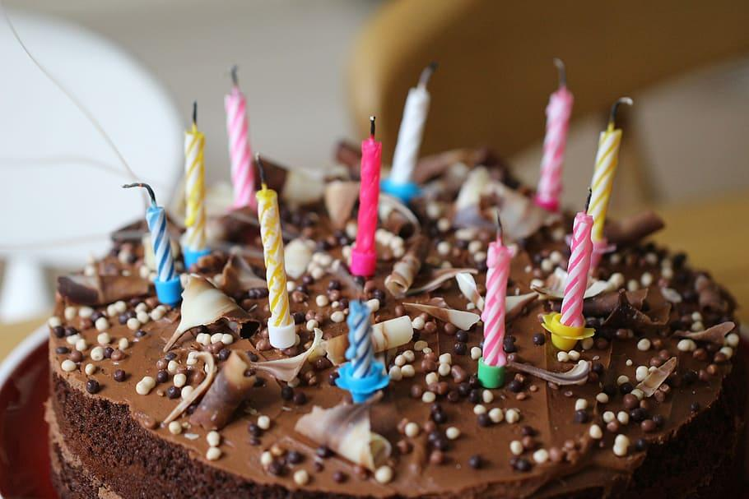

Happy Birthday!
October Birthdays

CORA H. GOODNO 10/03
MAC MCLAUGHLIN 10/03
CHARLES WIEHER 10/06
SANDRA BURNETT 10/08
DEANNA CHESSER 10/08
CHARLES PERRY 10/11
SANDY VALERIO 10/13
DENIELLER CHARRON 10/14
NORALEE ITCHOAK 10/14
LYLE HJORT 10/16
GREG BURNETT 10/17
SUZANNE WATKINS 10/21
LAUREL BAIRD 10/23
JANICE SUOJA 10/31

CRANBERRY APPLE CAKE https://thesaltycooker.com/cranberry-apple-cake/

2 cup sugar

½ cup milk

3 eggs

½ tsp kosher salt

2 cup gluten-free flour or all purpose flour

1 tsp baking powder

¾ cup butter - room temperature

2 tsp vanilla extract

2 tsp lemon zest

12 oz fresh cranberries

1 ½ cup grated apple

½ tsp cinnamon

⅛ tsp ground nutmeg

Topping

⅓ cup powdered sugar

Directions

Preheat your oven to 350 degrees Fahrenheit (175°C).

Spray a 9x13-inch cake pan with nonstick baking spray, ensuring an even coating to prevent sticking.

In a mixing bowl, combine the sugar, room-temperature butter, and lemon zest. Use an electric mixer to blend these ingredients for about 3 minutes until well combined and slightly creamy.

Add the eggs one at a time, mixing each one thoroughly before adding the next.

Mix in the milk until the mixture is well incorporated.

Add all the dry ingredients: gluten-free flour, kosher salt, baking powder, vanilla extract, cinnamon, and ground nutmeg. Mix until just incorporated; be careful not to overmix.

Fold in the fresh cranberries and the grated apple. This will give your cake a delightful fruity texture and flavor.

Pour the cake batter into the prepared 9x13-inch cake pan, spreading it evenly.

Bake in the preheated oven for 45-55 minutes or until a toothpick inserted into the center of the cake comes out clean. The top should be lightly browned.

Once baked, remove the cake from the oven and allow it to cool completely on a cooling rack.

After the cake has cooled, dust it heavily with powdered sugar for a sweet and decorative finish.

Slice and enjoy.




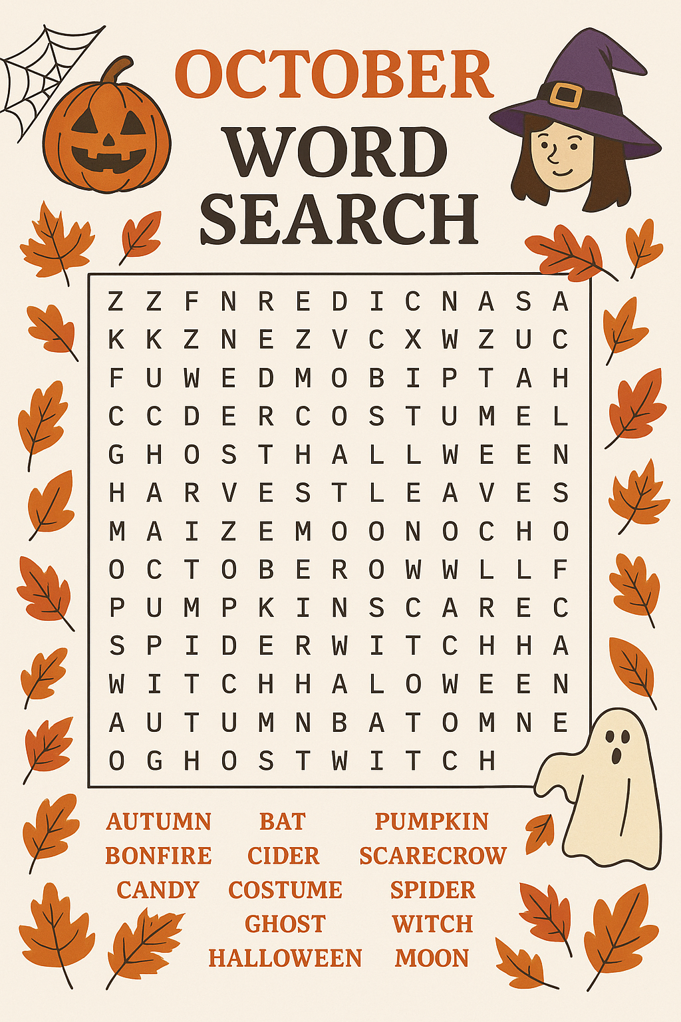



Please call to schedule your appointment today.
Each person must make an appointment. Can not share time slots

Sunday | Monday | Tuesday | Wednesday | Thursday | Friday | Saturday
 |  |  | 1  HH Open 11-3  Chair Yoga  10:30 - 11:30  Walkers 10 | 2  Dinner 5-6:30  Pasta with Italian Sausage | 3  HH Workday 10-1  Chair Yoga  10:30-11:30  BINGO | 4  Community  Breakfast 9-11  HH Open 11-3
5 | 6  Chair Yoga  10:30-11:30  Walkers 10  Pinochle | 7  HH workday  10-1  Mah Jongg  12:00-4 | 8  HH Open 11-3  Chair Yoga  10:30 - 11:30  Walkers 10 | 9  Movie 11  Dinner 5-6:30  Roasted Pork loin/vegetable | 10  HH Workday 10-1  Chair Yoga  10:30-11:30  BINGO | 11  HH Open 11-3  Quilters
12 | 13  Chair Yoga  10:30-11:30  Walkers 10  Pinochle  Columbus Day | 14  HH Workday  10-1  Mah Jongg  12:00-4 | 15  HH Open 11-3  Walkers 10  Chair Yoga  10:30 - 11:30 | 16  Dinner 5-6:30  Tacos with Rice | 17  HH Workday 10-1  Chair Yoga  10:30-11:30  BINGO | 18  HH Open 11-3
19 | 20  Chair Yoga  10:30-11:30  Walkers 10  Pinochle | 21  HH Workday  10-1  Mah Jongg  12:30-4  BOD Meeting  11am | 22  HH Open 11-3  Chair Yoga  10:30 - 11:30  Walkers 10 | 23  HEA Community Meeting  @ VFW  5-6:30 pm | 24  HH Workday 10-1  Chair Yoga  10:30-11:30  BINGO | 25  HH Open 11-3  Quilters
26 | 27  Chair Yoga  10:30-11:30  Pinochle  Walkers 10 | 28  HH Workday  10-1  Mah Jongg  12:00-4 | 29  HH Open 11-3  Chair Yoga  10:30 - 11:30  Walkers 10 | 30  Dinner 5-6:30  Meatball Sub with french fries | 31  HH Workday 10-1  Chair Yoga  10:30-11:30  TRUNK OR TREAT  BINGO  Halloween 🎃 |   October Flowers Cosmos & Marigolds

Anchor Point Senior Center
72750 Milo Fritz /
PO Box 438
Anchor Point AK 99556




